Help Support Empower
Early Help Strategy
2019 - 2022
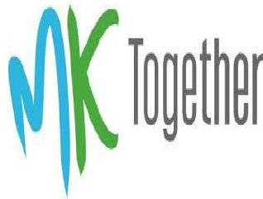

Contents page
Introduction
National context
Local context
What is Early Help?
Why is Early Help important?
Vision and principles
Priorities
Key Partners in the Delivery of Early Help
Measuring Impact
Resources and Workforce Development
Early Help pledge to families
Further information
2

This document sets out the commitment to early support for families in Milton Keynes to improve outcomes for children, young people and their families. It has been developed through Milton Keynes Safeguarding Partnership with the shared vision that every child in Milton Keynes should have the opportunity to reach their full potential and that children are best supported to achieve these outcomes within their own families.
Introduction
The Early Help offer advocates a strengths based approach recognizing the
resources and resilience that already exist in families and communities; enabling
children to grow up to be independent and resilient adults. In order to be effective early help needs to be easily accessed and flexible to prevent escalation that may need more specialist service involvement.
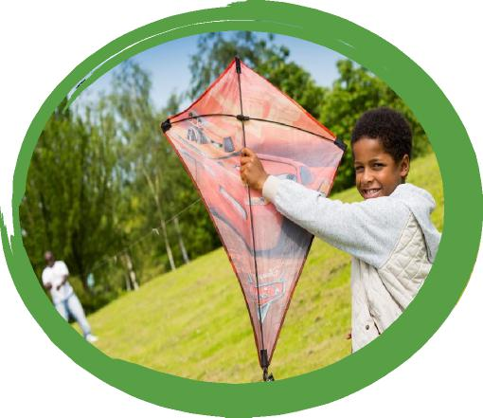
Milton Keynes Early Help offer aims to support children and families to ensure that they benefit from timely and focused support that is evidence informed. The aim of early help is to effectively intervene to reduce the risk of harm and difficulties becoming entrenched.
For early help to be effective it needs a whole systems approach to deliver both a universal and coordinated offer. This will be universal providers such as schools, children centres, health visiting and school nursing or a GP practice. The coordinated offer in children’s social care is achieved by bringing together a number of teams and services to create locality based Children and Families Practices that provide an integrated early help casework service and have aligned children’s centres and youth services to these localities.
The Milton Keynes Early Help approach can be seen within the ‘Levels of need when working with children, young people and their families’ document to support a shared understanding of the thresholds for intervention across agencies and between early help and more specialist services.
3

The ‘Levels of Need’ document is available at:
https://www.mktogether.co.uk/wp-content/uploads/2020/09/fv_MK-Levels-of-Need-July-2020.pdf
The early help review is being achieved with the support of the Milton Keynes Safeguarding Board and is progressing with the following priorities:
- Map existing services and provision, including any service gaps or capacity concerns.
- Analysis of multiagency assessment.
- Clarification of thresholds and service eligibility.
- Develop a shared understanding of when and how to escalate concerns.
- Identify any new tools or pathways needed for effective practice across agencies.
A multi-agency ‘task and finish’ group met several times to drive this work forward and considered in detail the scope of early help in Milton Keynes and the approach and pathways that need to be in place to make it effective. This group will now work together to develop an action plan covering the six agreed priorities and agreeing meaningful corresponding performance indicators.
In Milton Keynes we are committed to early help being a partnership approach that needs to span all agencies including health, education, social care, community, voluntary sector and the police.
Schools are central to providing early help and supporting children and families through pastoral systems, effective use of the Pupil Premium, and strategically through the implementation of the behaviour and inclusion strategies. It is important that all partners recognise the important role of schools in the provision of early help.
This document sets out the Early Help offer in Milton Keynes; this can be accessed via our Early Help website:
4
https://www.milton-keynes.gov.uk/children-young-people-families/early-help

Several key reports have been published that support the need for Early Help¹. The Allen report on intervening early in a child’s life; the Field report on preventing generational poverty; the Munro review of children’s care services; the Tickell review of early years; and the Marmot review of health. All make a strong and evidence-based case for early help asserting that no agency can provide this support alone and that greater coordination and joint working across and within agencies is required.
National Context
Recommendation 10 of Munro’s report advises that local authorities and other partners should secure sufficient provision of local early help services, as well as set out the arrangements for early help.
All providers of services for children, young people and families are working within a changing environment. Many local authorities also have unprecedented challenge, as demand for specialist services has rapidly increased against a setting of reducing resources. A number of national drivers impact on the delivery of early help services and therefore the development of this strategy.
Working together to safeguard children 2018
This is statutory guidance on inter-agency working to safeguard and promote the welfare of children. It includes specific guidance on early help, referring to the importance of organisations working together to identify children, young people and families who could benefit from early help services, and outlining key issues around assessment, referrals and thresholds for support.
“The wider, long term benefits that accrue to the whole of society have the potential to provide the biggest payoffs. They are critical to understanding the value of early intervention and why it should be prioritised.”

Bibliography
¹Allen (2011), ‘Early Intervention, the Next Steps’ and ‘Early Intervention: Smart Investment, Massive Savings’; Field (2010), ‘The Foundation Years: preventing poor children becoming poor adults’; Munro (2011), ‘Part One: A System Analysis’, ‘Part Two: The Child’s Journey’ and Part Three: A Child Centred System’; Tickell (2010), ‘The Early Years: Foundations for life, health and learning’ and Marmot (2010), ‘Fair Society, Healthy Lives’
5

Realising the Potential of Early Intervention, EIF (2018)
Milton Keynes is now around the size of a large outer London borough and about as diverse. Our estimated population is 267,530 with a vision of 500,000 by 2050. Milton Keynes has a relatively young population profile with children and young people under the age of 20 years making up 28% of the population, compared with an average of 24% in England as a whole.
Local Context
Our population is diverse 43% of school children are from a minority ethnic group compared with the England average of 32 %. (2018 data)
Despite the economic success enjoyed by many, disadvantage is a stubborn problem, and we rank alongside places like the Isle of Wight, Reading and Medway for child deprivation. Health inequalities are also a challenge for us. Although MK is less than England’s average for deprivation, 14% of our population, some 37,000 people, including 10,000 children (17%) are living in the 20% most deprived areas of England.
The Council Plan gives a high priority to children and our Health and Wellbeing Strategy sets the course for further improvement over the next decade. Financially, things are stable. The Council’s budget for children’s services for 2018/19 was £43.9M, up from £42.1M in 2017/18 and it continues to support a very wide range of preventative and community services, such as our significant network of children and family centres. Our commitment to partnership working is very strong. We’ve successfully streamlined the way we work together – for example, establishing a joint children and adults safeguarding board (MKSB).

6

- Early help is not just for children in their early years. The Need for support can occur at any point throughout childhood (including pre-birth) and adolescence.
“Early help offers a range of universal and targeted support to help identify and resolve needs and concerns for children and young people and their families as soon as possible.”
What is Early Help?
Definition:
- Early help is about intervening at the earliest point to maximize the chances that interventions can be effective and quickly make a lasting impact for families.
- Early help is about all services understanding what they can do to contribute to positive and holistic change for families.
- Early help can be provided through a number of universal or targeted services.
- Making every contact count through all those who work with children and young people and their families being pro-active and inquisitive to ensure needs are met.
- We will empower and support families to find their own solutions and take responsibility for their future.
- To provide an effective Early Help offer services need to work together and understand the contribution that each brings.
- Early help should consider the whole family needs, working holistically and strengthening families’ links to community based resources.
- Within Children’s Social Care the Early Help offer is underpinned by a Family Support Approach so when there are significant safeguarding concerns, we can support children and families to live in safe and secure settings that give them the best opportunities to thrive and prosper.

7

Recent key reports highlight how early and effective support can have a range of positive impacts on children, young people and their families such as:
Why is Early Help important?
8
- Children and young people have improved prosocial skills and behaviour.
- Parents and carers are able to provide attachment and nurture for children and young people. Families are able to look after themselves and manage difficulties.
- Children, young people and their families have improved physical and mental wellbeing.
- Early help has economic benefits by reducing the number of families requiring higher level specialist services.
- Children and young people are able to reach their full potential with their schooling and are equipped for their adult lives including healthy relationships, job prospects and wellbeing.
- Early help consists of all the support available to children and families at levels 1, 2 and 3 of the four levels of need. It also enables children and young people moving away from statutory support (level 4); to sustain the progress they have achieved and promote their increasing independence.
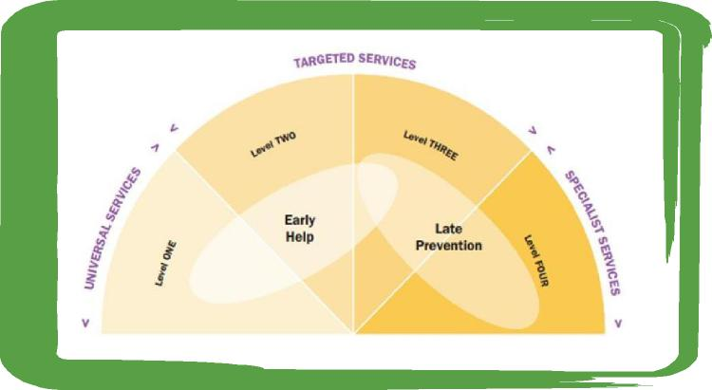

“We will work together to make sure that all children, young people and their families in Milton Keynes are; safe, happy, are able to thrive and are equipped to deal with life’s challenges. “
Visions and Principles
Milton Keynes Safeguarding Partners have agreed to the following four principles for early help:
- A strong universal offer
That supports all Milton Keynes families from pre-birth, early years to adolescence;
that is clearly communicated and accessible.
- A collaborative approach
All families to receive the right support at the right time through using a joined up approach to assessment, planning and support.
- Clear pathways for support
Avoiding duplication by Milton Keynes partners using a singular process and sharing
information in an effective and appropriate manner.
- Measuring Performance
Robust use of data to better understand the effectiveness of early help provision and to continuously learn and make improvements.
9
To target resources effectively to support children and their families as early as possible when problems arise.
Priorities
- To monitor and measure the impact of the Early Help offer through assessment processes and performance management.
- To build on the strengths and capacity of families and communities to meet children’s needs through universal services where possible.
- To prevent the need for referral and thereby reduce the number of children requiring specialist and statutory support.
- To support children to thrive by intervening to improve key protective factors that help build resilience.
- To support the Early Help model to thrive through shared understanding and responsibility across partners.
Having identified priorities in Milton Keynes partners will now collaborate in developing an action plan to progress these priorities

10

Children aged 0-5
Key Partners in the Delivery of Early Help
– Midwife; health visitor
– Children and Family Centres
–Early years and childcare providers
– Early years SEND support
– Voluntary and Community Sector
– Children and Family Practices
School age children
– Schools
– SEND Local Offer
– Children and Family Practices
– School Nursing
– Voluntary and Community Sector
– School attendance, children missing education and
home education
Young people aged 13+
– Schools
– Targeted Youth Support
– Youth participation
– Voluntary and Community Sector
– Children and Family Practices
– Youth Offending Team – prevention
Integrated Work with Families
Milton Keynes Early Help offer is focused on working with families. The four key enablers identified here as contributing to effective work with families are establishing a safe and effective front door (The Multi-Agency Safeguarding Hub – MASH); focusing on the needs of
11

the family as a whole; deploying a practice model based on evidence; and promoting resilience and being responsive.
The MASH provides a single point of initial assessment and triage to make sure that the family is directed to the most appropriate pathway and support. Staff that are from partner agencies such as health and the police are often formally engaged in supporting these decisions. However, not all referrals are made to the MASH and a good early help model recognises that other services are available to help; for example, a health visitor might refer a family to a children’s centre.
By focussing on the needs of the family as a whole, rather than the individual, this allows the family to tell their story once to trigger a joined-up and multi-agency response. The assessments in use allow partnership colleagues to address the underlying needs, rather than the presenting symptoms. Additionally the family focus of early help promotes a more co-ordinated approach to providing support.
Effective early help should focus on building a family’s resilience and capacity, as well as their ability to recognise their own needs and requirements. To achieve this support should be flexible and jointly developed and agreed between the key workers and the family to focus on building the skills and coping mechanisms required to sustain progress independently.
Local Authority teams that contribute to the Early Help offer bring a range of skills and expertise in key areas such as SEND, youth work, parenting and early years. Integrated working as a team around the family ensures that the support offered is appropriate both in terms of age and the issues. Our successful approach to the national Troubled Families Programme, known locally as Strengthening Families, improves the life chances of families with multiple problems through joining up local services. The community and voluntary sector in Milton Keynes adds greater community and individual resilience to promote independence and reduce reliance on formal service provision.
Central to the Early Help Offer is the voices of children and young people; work with the Youth Cabinet representatives on their priorities to combat mental health issues and promote life skills education is key.
The Early Help offer will be timely, responsive and flexible, available to those in need and, by establishing and maintaining strong links to schools, early years settings and health providers we will increase our ability to work together for the benefit of the children and families who need our support.

12

The partnership is developing a framework of core performance indicators that align to the agreed priorities to evidence the impact of our early help support in key areas which impact on children’s outcomes. We will include feedback directly from children, young people and families to understand the impact that we have on their lives. National and peer group benchmarking will be used to support the partnership drive to improve outcomes.
Measuring Impact
Central to this is the importance of developing management information systems to allow partners to engage with meaningful data and remove barriers to data sharing across services and allow agencies to track progress made with vulnerable families.
Auditing and quality assuring practice ensures that the practice model for working with families is being implemented well.
We also want to ensure we are delivering coordinated Early Help provision that is meeting the needs of our communities and is proactively recognising the changes in our growing city. We continue to be ambitious in the outcomes we want to achieve and be innovative in our practice, ensuring personalised approaches that meet the needs of our children and families.
The drivers behind our work challenge us to be ambitious, impactful and aspirational in what our children and families can achieve.

13

Work force strategy to take forward
Resources and Workforce Development
Core services, managed by the local authority, delivered intensive early help interventions on a key-worker model although a range of different teams and professional disciplines are brought together into an integrated key worker service.
Partner agencies also play a critical role in the delivery of early help through engagement in strategically shaping the vision, setting the objectives and describing the offer. A culture of professional trust is essential to enable more operational partnership working to flourish, for example in supporting partners to be effective lead professionals.
Milton Keynes council have invested in training staff to create a shared culture and way of working that crosses professional boundaries and disciplines. The Leadership and Governance Team have significant experience in delivering training sessions for schools and settings, and deliver some key safeguarding children training courses on behalf of the Milton Keynes Safeguarding Board. The Professional Development Centre has been developed to become a dedicated training and development centre and has the support and IT infrastructure in place to ensure regular delivery of these key courses to partners across Milton Keynes.
Thematic multi-agency training covering issues such as domestic abuse, parenting and adverse childhood experiences (ACE) have been offered across the partnership to raise better understanding of these, and other, key issues with colleagues involved in early help and intervention services.
Further development opportunities have been identified to support colleagues in working to the same assessment, reporting and outcomes framework as other early help practitioners.
14

Early help is everyone’s responsibility.
Early Help Pledge to Families
- Identify needs and concerns early
- Make sure that children, young people and their families can easily access early help, at the right time, by the right organisation(s)
- Empower and support families to find their own solutions and take responsibility for their future
- Develop and publish our Early Help offer
- Share learning in order to improve and ensure better outcomes for all
- Have a named Early Help Coordinator
- Train staff to effectively undertake their role in the provision of early help
This pledge expresses Milton Keynes commitment to early help.
15

Further Information
See the Early Help website for more about the early help process and tools and for the A-Z of early help services:
https://www.milton-keynes.gov.uk/children-young-people-families/early-help

